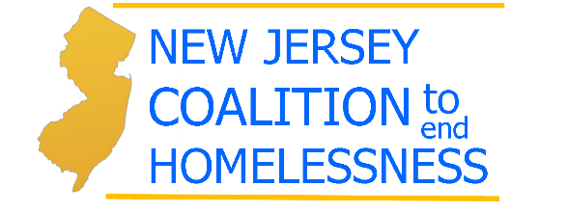

c/o Lowenstein Sandler, LLP
65 Livingston Avenue, Suite 412 West
Roseland, NJ 07068

August 1, 2014
Via Email: COAHAdmin@dca.state.nj.us
Sean Thompson, Acting Executive Director
NJ Council on Affordable Housing
PO Box 813
Trenton, NJ 08625-0813

Re: Comments on the proposed COAH Third Round Substantive Regulations, N.J.A.C. 5:99, 46
N.J.R. 924, and Procedural Regulations, N.J.A.C. 5:98, 46 N.J.R. 912

Dear Mr. Thompson:

These comments are submitted by the New Jersey Coalition to End Homelessness, a statewide advocacy group with one mission: to end homelessness. The Coalition’s members include shelter providers, social service agencies, housing organizations and individual advocates.

The Coalition has also signed on to the comments submitted by the Housing and Community Development Network of New Jersey, which address the many ways that the proposed rules will severely reduce housing throughout the state. The Coalition is submitting these separate comments in order to emphasize how the lack of affordable rental housing in New Jersey leads to homelessness.

It is a travesty that the proposed rules contain absolutely NO requirement for rental housing. Towns can meet their entire obligation without any homes for families, seniors, or people with special needs who need rental housing, which is a change from all prior versions of the COAH rules. If the rules are adopted without any requirement for rental housing, New Jersey can expect to see further increases in its homeless population, because homelessness is caused by a lack of affordable homes.

Homelessness in New Jersey is substantial and growing. According to the 2014 Point in Time Count of homeless individuals, on the single night of January 28, 2014, there were 13,900 New Jersey citizens who were homeless, an increase of 15.8% over the number in January 2013. A number of factors combine to make finding affordable rentals particularly difficult for those with extremely low incomes, defined as individuals whose income is less than 30 percent of the area median:
- Our high rate of unemployment,
- Our high cost of housing,
- Our general lack of affordable housing,
- The destruction of substantial amounts of affordable housing due to Hurricane Sandy.

While New Jersey is often cited as one of wealthiest states in the nation, the high cost of living is usually ignored, as are the large number of our citizens who are extremely low income. A study by the Bureau of Economic Analysis shows that New Jersey ranks among the highest in the nation for expenditures such as rent, education, food, and medical. At the same time, median incomes adjusted for inflation were lower in 2011 than in 2006, and wages have been declining steadily.

Extremely low income households are particularly affected by the shortage of affordable rental housing. According to a report by the National Low Income Housing Coalition in 2013, the deficit of units that are both affordable and available to extremely low-income renters is about 188,974 units. Put another way, for every 100 ELI renters in the state, there are only 31 units that are both affordable and available.

High rental costs due to shortages of units combined with low wages create “severe housing cost burden” that is a significant cause of homelessness. According to a recent study by the National Alliance to End Homelessness, between 2011 and 2012 severe host cost burden increased in New Jersey almost 10%, from 143,520 to 157,401 households, even though it decreased in 25 other states.

For individuals and families who are either homeless or at risk of homelessness, the lack of affordable rental housing is not an abstract concept, but is why they live in the street, in a homeless shelter, or in a motel with drug addicts. The lack of affordable rentals can make it impossible for domestic violence victims to exit shelters or veterans to find a home of their own.

We urge the Council on Affordable Housing to include rental housing in its rules so that the most vulnerable citizens among us have access to safe, affordable rental housing.

Sincerely,

Deborah Ellis
Executive Director
dellis@njceh.org

Legal Services of New Jersey, Poverty Benchmarks (2013), page 7-8.
Id. At 131.
National Alliance to End Homelessness, The State of Homelessness in America in 2014, 52-54.

